**Nginx Container in Kubernetes using a deployment**

**Commands:**

* sudo nano nginx-deployment.yml
* kubectl apply -f nginx-deployment.yml
* minikube start
* kubectl apply -f nginx-deployment.yml
* kubectl get pods
* kubectl get svc
* minikube ip

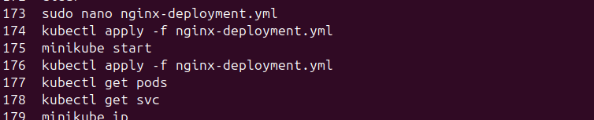

**After entering the sudo nano nginx-deployment.yml**

apiVersion: apps/v1

kind: Deployment

metadata:

name: nginx-login

spec:

replicas: 1

selector:

matchLabels:

app: nginx-login

template:

metadata:

labels:

app: nginx-login

spec:

containers:

- name: nginx-login

image: nginx:latest # Public Nginx image from Docker Hub

ports:

- containerPort: 80

---

apiVersion: v1

kind: Service

metadata:

name: nginx-login-service

spec:

type: NodePort

selector:

app: nginx-login

ports:

- protocol: TCP

port: 80

targetPort: 80

nodePort: 30008 # NodePort exposes service on this port

Ctrl+O followed by Ctrl+X

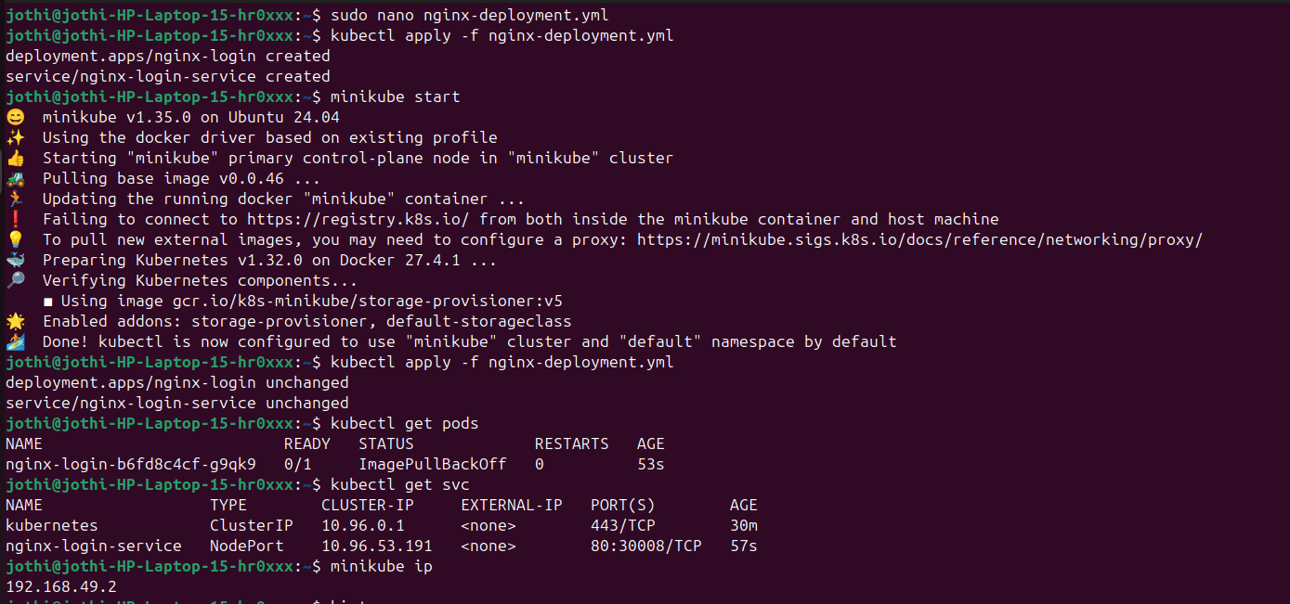

* The **container listens on port 80**.
* Kubernetes exposes it **on NodePort 30008**.
* It uses **TCP protocol**.

Open in a Browser using ip address and node port

**http://192.168.49.2:30008/**

**OUTPUT:**

